**SQL QUERIES ON RETAIL STORE DATASET:**

**KPI’s:**

1. **TOTAL REVENUE**:

SELECT SUM(Sales) AS total_revenue FROM store_sales;

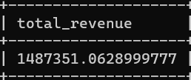

1. **TOTAL ORDERS**:

SELECT COUNT(DISTINCT order_id) AS total_orders FROM store_sales;

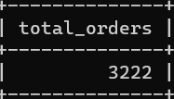

1. **AVERAGE ORDER REVENUE:**

SELECT (SUM(sales) / COUNT(DISTINCT order_id)) AS avg_order_revenue FROM store_sales;

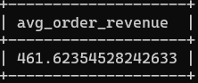

1. **TOTAL SOLD:**

SELECT SUM(quantity) AS total_sold FROM store_sales;

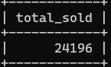

1. **AVERAGE GOODS SOLD PER ORDER:**

SELECT CAST(CAST(SUM(quantity) AS DECIMAL(10,2)) /

CAST(COUNT(DISTINCT order_id) AS DECIMAL(10,2)) AS DECIMAL(10,2))

AS avg_goods_per_order

FROM store_sales

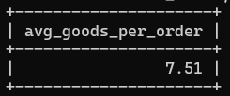

**TIME ANALYSIS:**

**DAILY TRENDS:**

1. **TOTAL ORDERS PER DAY OF WEEK:**

(**Changing datatype of order_date from text to date:**

UPDATE store_sales

SET `order_date` = STR_TO_DATE(`order_date`, '%m/%d/%Y'); )

SELECT DAYNAME(order_date) AS order_day,

COUNT(DISTINCT order_id) AS total_orders

FROM store_sales

GROUP BY DAYNAME(order_date);

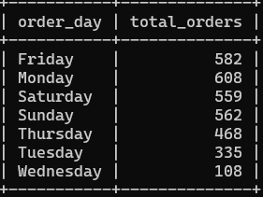

**MONTHLY TRENDS:**

1. **TOTAL ORDERS PER MONTH:**

SELECT MONTHNAME(order_date) AS order_month,

COUNT(DISTINCT order_id) AS total_orders

FROM store_sales

GROUP BY MONTHNAME(order_date);

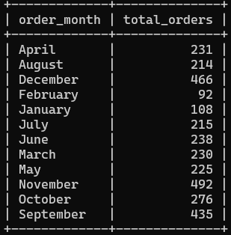

**PRODUCT ANALYSIS:**

1. **SALES % FOR EACH CATEGORY:**

SELECT category, CAST(SUM(sales) AS DECIMAL(10,2)) as total_revenue, CAST(SUM(sales) * 100 / (SELECT SUM(sales) from store_sales) AS DECIMAL(10,2)) AS percentage

FROM store_sales

GROUP BY category;

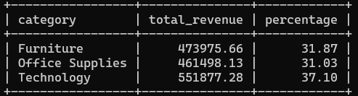

1. **SALES % FOR EACH SUB-CATEGORY:**

**(Altering column name “Sub-Category” to Sub_Category:**

ALTER table store_sales

CHANGE COLUMN `Sub-Category` Sub_Category text; )

SELECT Sub_Category, CAST(SUM(sales) AS DECIMAL(10,2)) as total_revenue, CAST(SUM(sales) * 100 / (SELECT SUM(sales) from store_sales) AS DECIMAL(10,2)) AS percentage

FROM store_sales

GROUP BY Sub_Category;

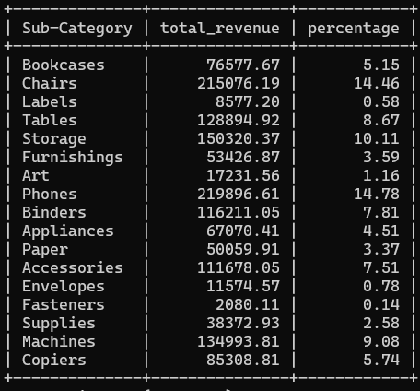

1. **TOTAL GOODS SOLD BY CATEGORY:**

SELECT Category, SUM(quantity) AS total_sold

FROM store_sales

GROUP BY Category;

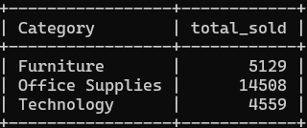

1. **TOTAL GOODS SOLD BY SUB-CATEGORY:**

SELECT Sub_Category, SUM(quantity) AS total_sold

FROM store_sales

GROUP BY Sub_Category;

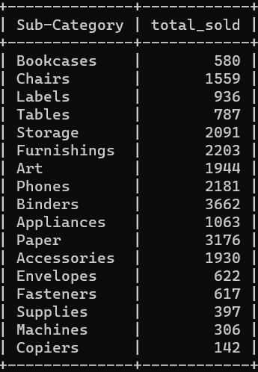

1. **TOP 5 PRODUCTS BY REVENUE:**

**(Altering Column name “Product Name” to Product:**

ALTER table store_sales

CHANGE COLUMN `Product Name` Product text; )

SELECT Product, Sales as Revenue

FROM store_sales

ORDER BY Revenue DESC

LIMIT 5;

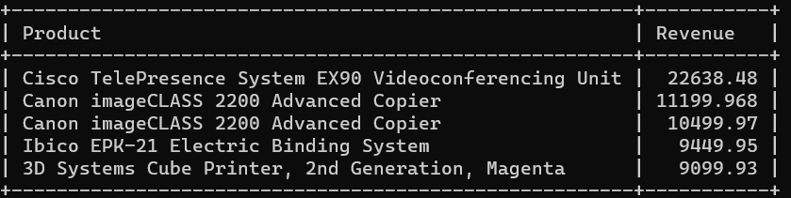

1. **TOP 3 CATEGORIES BY REVENUE:**

SELECT Category, SUM(Sales) as Revenue

FROM store_sales

GROUP BY Category

ORDER BY Revenue DESC;

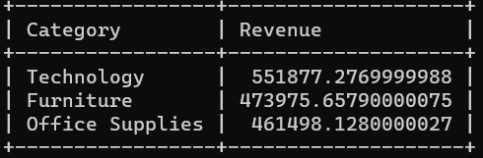

Note: Here, we have only 3 categories so the above query just sorts them in descending order with respect to revenue.

1. **TOP 5 SUB-CATEGORIES BY REVENUE:**

SELECT Sub_Category, SUM(Sales) as Revenue

FROM store_sales

GROUP BY Sub_Category

ORDER BY Revenue DESC

LIMIT 5;

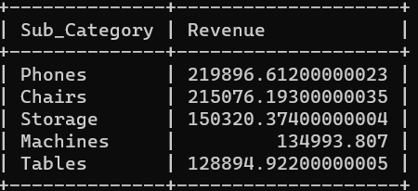

1. **TOP 5 PRODUCTS BY TOTAL ORDER:**

SELECT Product, COUNT(DISTINCT order_id) as total_order

FROM store_sales

GROUP BY Product

ORDER BY total_order DESC

LIMIT 5;

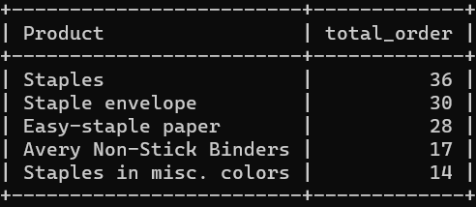

1. **TOP 3 CATEGORY BY TOTAL ORDER:**

SELECT Category, COUNT(DISTINCT order_id) as total_order

FROM store_sales

GROUP BY Category

ORDER BY total_order DESC

LIMIT 3;

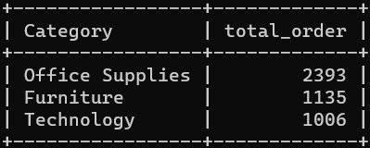

Note: Here, we have only 3 categories so the above query just sorts them in descending order with respect to total orders.

1. **TOP 5 SUB-CATEGORY BY TOTAL ORDER:**

SELECT Sub_Category, COUNT(DISTINCT order_id) as total_order

FROM store_sales

GROUP BY Sub_Category

ORDER BY total_order DESC

LIMIT 5;

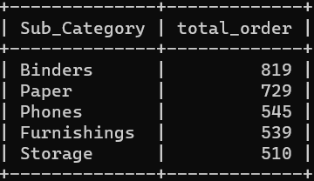

1. **TOP 3 CATEGORY BY PROFIT BY SALES %**:

SELECT Category,SUM(Sales) AS Sales, SUM(Profit) AS Profit, CAST(SUM(Profit)*100/SUM(Sales ) AS DECIMAL(10,2)) AS Profit_by_Sales_Percentage

FROM store_sales

GROUP BY Category

ORDER BY Profit_by_Sales_Percentage DESC

LIMIT 3;

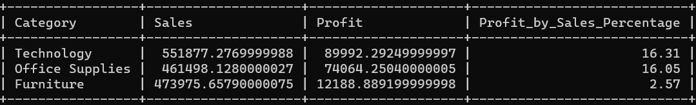

1. **TOP 5 SUB-CATEGORY BY PROFIT BY SALES %**:

SELECT Sub_Category,SUM(Sales) AS Sales, SUM(Profit) AS Profit, CAST(SUM(Profit)*100/SUM(Sales) AS DECIMAL(10,2)) AS Profit_by_Sales_Percentage

FROM store_sales

GROUP BY Sub_Category

ORDER BY Profit_by_Sales_Percentage DESC

LIMIT 5;

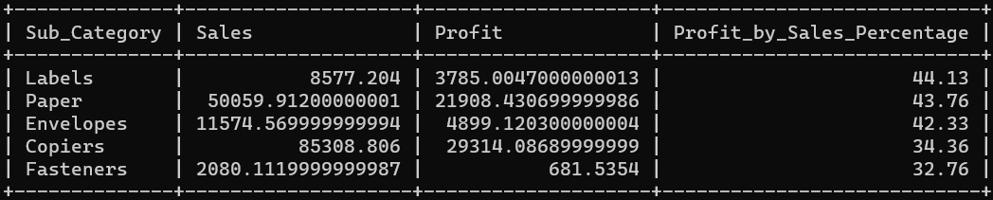

1. **TOP 5 PRODUCT BY PROFIT BY SALES %**:

SELECT PRODUCT, SUM(Sales) AS Sales, SUM(Profit) AS Profit, CAST(SUM(Profit)*100/SUM(Sales) AS DECIMAL(10,2)) AS Profit_by_Sales_Percentage

FROM store_sales

GROUP BY PRODUCT

ORDER BY Profit_by_Sales_Percentage DESC

LIMIT 5;

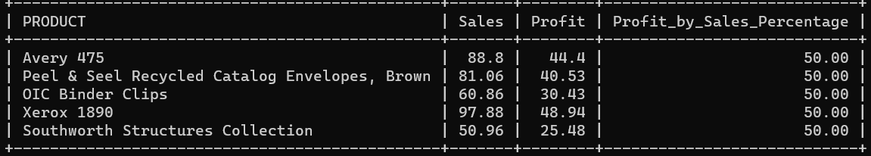

**CUSTOMER ANALYSIS:**

1. **TOP 5 CUSTOMERS TO GENERATE MOST OF SALES OR REVENUE:**

**(Altering Column name “Customer Name” to Customer:**

ALTER Table store_sales

CHANGE COLUMN `Customer Name` Customer text; )

SELECT Customer, SUM(Sales) AS Sales

FROM store_sales

GROUP BY Customer

ORDER BY Sales DESC

LIMIT 5;

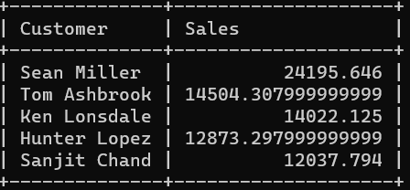

1. **TOP 5 CUSTOMERS WITH MAXIMUM PROFIT BY SALES %:**

SELECT Customer, SUM(Sales) AS Sales, SUM(Profit) AS Profit, CAST(SUM(Sales)*100/SUM(Profit) AS DECIMAL(10,2)) AS Profit_by_Sales_Percentage

FROM store_sales

GROUP BY Customer

ORDER BY Profit_by_Sales_Percentage DESC

LIMIT 5;

